Aeneas’ Journey from Google Maps

Aeneas’ Journey from Google Maps. The purple line points to all the places Aeneas went. The names are with the red arrows. You can use those for your project.

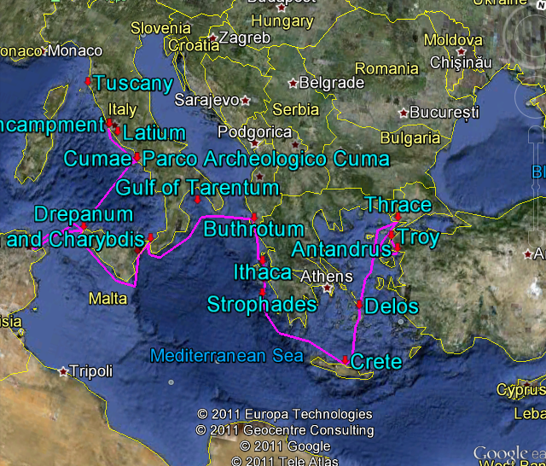

The Trojans **(find Troy on the map)** sailed with their own gods, the Lares *(household gods – usually family ancestors)* and Penates *(more household gods)*, from their city Troy. They had been ordered to look for 'New Troy.' Aeneas agreed to go find it but where was this “New Troy”?

At first, they sailed to Thrace **(look on the map above Troy)** because there was a man named Polydorus. He was a Trojan, who had been killed by the Greeks. His ghost called out from his grave *(scary – a ghost talking to Aeneas!)*. “Thrace is not the place for the new city of the Trojans, who are following Aeneas.” So, now where should Aeneas look? He has no clue but gets back in the ship and sails to Delos **(look on the map above)**.

On the island of Delos, a fortune teller *(oracle is the word we use)* said, “Seek the ancient mother.” Well that wasn’t much help. Then Anchises, Aeneas’ dad, remembered, “Teucer, the founder of the Trojans, sailed from Crete. Crete will be our country!” They all sailed to Crete.

But after the Trojans stayed for a year, experiencing a lot of really bad stuff on the island of Crete, in the city of Pergamus, the Lares (family gods) showed up in the middle of Aeneas’ dreams. They said, “Crete is not your fatherland. Hesperia is your fatherland. It was the fatherland of Dardanus, the father of the Trojans. There will be your fatherland.” So Aeneas and all who followed him got back into the ships to sail for a place called Hesperia. Where is was, they weren’t totally sure. But it had to be somewhere west. (Hesperia is another name for Italy. But Aeneas didn’t know that.)

Suddenly a great wind tossed the ships in a totally different direction. The Trojan ships came ashore in the land of the Harpies. (Harpies are scary monsters that are half bird and half women. They liked to steal food.) But Celaena, one of the Harpies, decided to help Aeneas. She also told him to go to Italy without using the name Italy. No wonder he was so lost.

[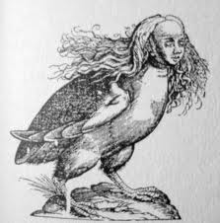](http://www.google.com/imgres?q=the+harpies&hl=en&sa=X&biw=1344&bih=662&tbm=isch&prmd=imvns&tbnid=hTYR-usOlGbqpM:&imgrefurl=http://www.facebook.com/pages/Queen-of-the-Harpies/115199827040&docid=EyFDAIjuwO4ZIM&imgurl=http://a5.sphotos.ak.fbcdn.net/hphotos-ak-snc1/s320x320/5774_115200477040_115199827040_2577635_2196215_n.jpg&w=316&h=320&ei=HJzfTs33Kejs2AXqpdyVBQ&zoom=1)

Someone remembered that Helenus, the son of king Priam, used to live near Actium (Buthrotum – see on the map). So they went to visit Helenus. He was a fortune telling priest and said, 'Your land is Ausonia, (another name for Italy). But first sail around Sicily (the triangle that looks like it is getting kicked by the boot – can you find it on the map?) and then proceed to Cumae **(see it on the map)**. In that land you will find a white pig with thirty piglets. There New Troy will be yours.'

If only these people would give Aeneas good directions and the ships wouldn’t get blown away, Aeneas could have been there quickly. But then we wouldn’t have a cool story. ☺

3Polydorus -- youngest Trojan prince; King Priam sent him and a shipment of gold from Troy to Thrace to be protected until the end of the war. When he realized the Trojans were losing, the Thracian King killed Polydorus for the gold

4Delos -- a small island in the Cyclades, the birthplace of Apollo

5Teucer -- Ancestor and king of the Trojans, who are also called the Teucri. He was the father-in-law of Dardanus

6progenitor -- (Look up this word in an English dictionary.)

7Creta -- Crete, an island in the Mediterranean

8Pergamus -- This was the name of the Trojans' town in Crete

9Hesperia -- land of the west, another name for Italy

10Dardanus -- son of Zeus and Electra. He sailed from Samothrace to Troas in a raft made of hides. Once he arrived there, he founded the city of Dardania, the later, ill-fated city of Troy

11Harpies -- mythological creatures with heads of women and bodies of birds

12Celaeno -- queen of the Harpies, who could predict the future

13Actium -- a harbor in western Greece, where another Trojan prince settled

14Helenus - - a Trojan prince, son of Priam

15Priam - - king of Troy

17Augur -- a priest who interprets omens

18Ausonia -- still another name for Italy